Green Team:

Angie Tracy

Jim Lilley

Micah Smith

Joseph Youskievicz

Bacchus Winery Case Study

Revised ERD:

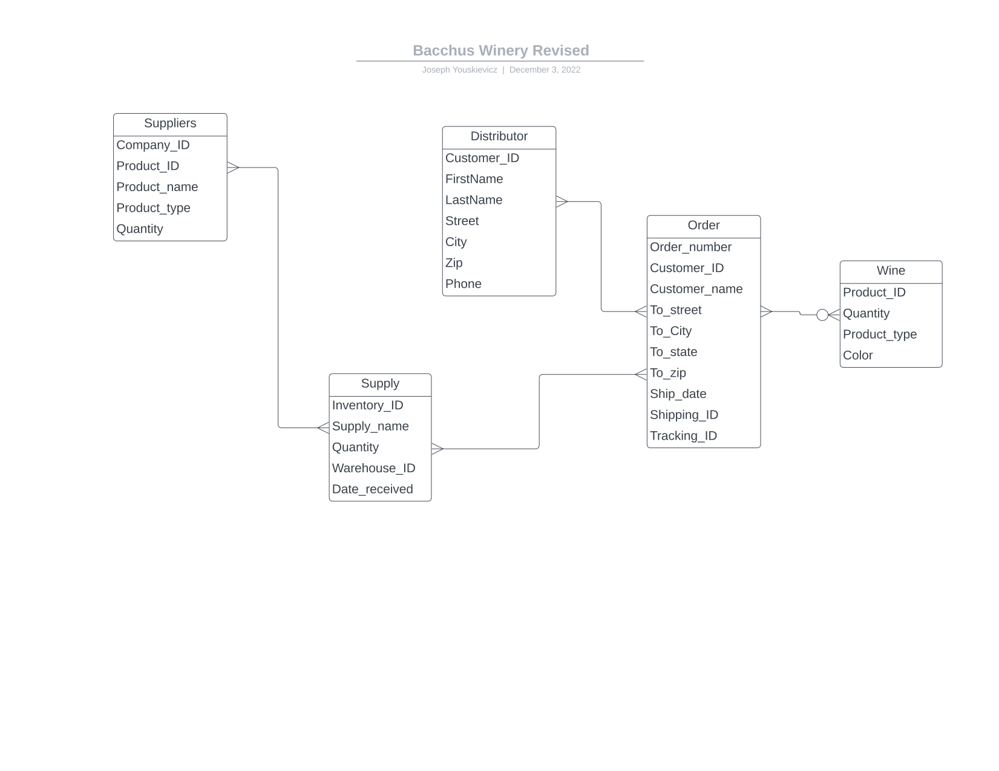

Screenshots of tables displayed:

| Suppliers and Supplies: | Wines |
| --- | --- |
| Suppliers_and_Supplies.png | Wines.png |

| Orders: | Distributors: |
| --- | --- |
| Orders.png | Distributors.png |